2014 Spring Update
Transforming lives through education
We give thanks for all the support we have received for the education of children in Africa.
All of you who are supporters of VillageSteps have been part of changing lives and the future of generations of families. Whether it has been money, prayers, labor or encouragement, it is deeply appreciated.

You have given hope to those who may have felt forgotten. This is especially true for girls whose education is often a lower priority for their families who expect daughters to assist with younger siblings, to do chores such as fetch water and firewood, and to marry young. The education of girls can be a threatening cultural change that is resisted. An extreme example of this is the Boko Harem in Nigeria.
Also, we acknowledge the tenacity of children who have chores at home and still walk to school to learn. Many of them have lost parents and have limited resources, but they have persevered.

PROJECTS
Progress at Healing Place School in Zambia.
We now provide a monthly stipend for the teachers and funds for school lunch each day.
The school has added grades 8 & 9, the reason is that we had pupils who were forced into early marriages and some were in the streets to look for money because after graduation to grade 8 they had no funds.
Number of pupils in each grade is as follows.  Pre grade one: 51,  grade one: 45,  grade two: 42  grade three: 53  grade four: 52  grade five: 41  grade six: 36  grade seven: 21  grade eight: 28  grade nine: 13. | 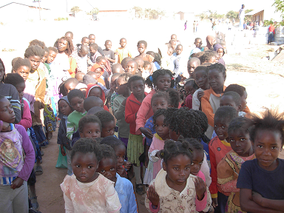
The total number of pupils is 382, with 217 girls and 165 boys. The total number of teachers is 12 and one care giver Jane. All the teachers have grade 12 certificates.
The school also does sports. For this reason we are in need of balls for netball, football (soccer) and sportswear for boys and girls.
In August, a team from Calvary Presbyterian Church in Enumclaw, Washington will travel to Lusaka to build a food/assembly hall for Healing Place. The health department has advised the school that a separate food hall is required to meet hygiene requirements.
A $5000 grant for Enumclaw Rotary will pay for most of the building supplies. Due to high inflation in Zambia, the cost of building materials for the hall has gone from $5000 to $6200. We hope to raise these additional funds before the team departs.

A new classroom building has been completed, providing four classrooms total.  Electricity is needed for security and better visibility.  A food/assembly hall is needed  In the future, a security wall is needed to protect school supplies and furniture. | 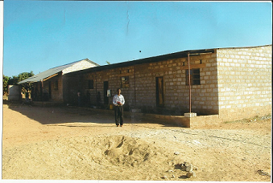

Preschool in Tanzania – Now Self-sufficient!
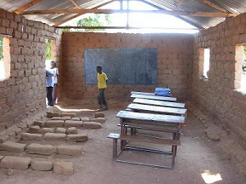 | 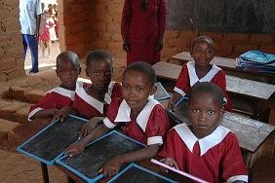

Now, through a micro-farming chicken project, the manager has been able to fund a new classroom and pay all expenses. He started by purchasing 500 chicks. This project now provides less expensive eggs for the remote village and all the funds for operating the school.

Egg project | New completed classroom!!
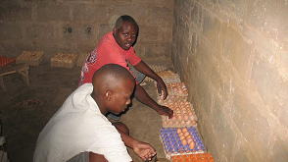 | 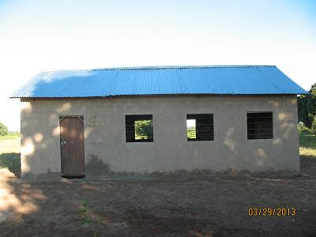

You have made a life changing contribution to children through your support. Please partner with us again to complete these schools and to provide scholarships for students to continue their education.

Remember 100% of your donation goes to the projects and students in Africa.

Part of Suzanne’s book sales go to VillageSteps.
The second novel in the Chitundu Trilogy is now published: titled The Academy.

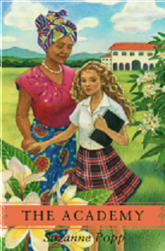 | The story continues the saga of the African family, with the construction of a school for girls, and the return of the English tutor. A new generation deals with the problems of a rapidly changing society.  Some of the proceeds from the sale of this novel and The Bride Price, also written by Suzanne Popp will go for scholarships for vulnerable children.  These books are available at Amazon.com.

Some opportunities to participate in 2014.

Provide scholarship for a student for one year  - Pre-school=$120  - Middle school=$250  - High School=$500  - University=$1400 | Electricity to the classroom blocks at Healing Place to improve security and to allow for evening studies=$1500.
Construction supplies for food/assembly hall at Healing Place. $1200 still needed. | Electricity to the food/assembly hall at Healing Place=$800.
American-made (Singer) sewing machines for guardians’ co-op at school for deaf=$600 each | Security wall from well at Healing Place School=$6500.

There is an African saying: If you educate a boy, you educate a man. If you educate a girl, you educate a village.

Send donations to VillageSteps at:
27455 SE 400th Way
Enumclaw, WA. 98022

Thank you and God bless you for your gifts.

Ken and Suzanne Popp
Directors
Email: poppvillage@msn.com

